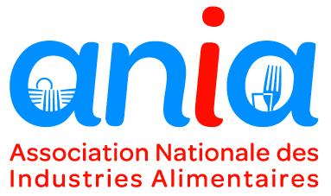

TENDER – BRIEF (JANUARY 2020)
SUPPORT FOR PROMOTION OF PROCESSED FRENCH FOOD PRODUCTS IN THE USA

context
The French Food and Drink Federation (ANIA, Association Nationale des Industries Alimentaires), is a non-profit association created in 1968. ANIA’s mission is to represent, inform and accompany French food processing companies from all over France (17 000 companies, of which 98% are SMEs). Its members include 37 sectoral syndicates and 15 regional federations.
Following discussions within ANIA’ Export Committee, ANIA was assigned in 2018 the mission to build a program aiming at helping food companies expand their exports and business relations in the United States of America. The main objective of the program was to increase the visibility, the sales and the general awareness of European and French food products in the US. The action aimed at widening the range of European and French products available via different American distribution channels. The 2019-2021 European Taste programme by ANIA has since then been a success: more than 150 companies have been accompanied in their implantation on the American market, through B2B meetings during Trade Fairs, buyers’ trips, In-Store promotions and communication actions.
As this first programme comes to an end in 2021, ANIA’s ambition is to continue its actions in the US for two more years, and to deepen the European and French’ enterprises’ presence on the American market. The recruitment of a specialized executive agency is necessary to plan and execute the actions covered in this new program.
ANIA expects a sustainable partnership with the executive agency; based on high mutual confidence, considering the budgets involved, considering the need to sustain companies’ confidence in ANIA via the proposed program, and considering that sensitive, confidential information of a competitive nature may be shared with the chosen agency.
This B2B-focused program will include the following activities:
- Public relations and communication
- B2B Roadshow
- Buyers’ trips
- In-store promotions
- Trade fairs
The two-years program aims at reaching once again over 150 companies and at strengthening the achievements of the first European Taste Program, with a budget of €900 000 available for execution of the actions by the executive agency.

ELEMENTS EXPECTED IN The bid
The detailed proposition (PowerPoint format demanded) should be sent imperatively in English to Ms. Vanessa QUERE (vquere@ania.net) and should include:

- Presentation of the agency including information on its financial viability, on its competences for accompanying ANIA with these 5 types of activities in the USA and on its knowledge on rules concerning EU-funded promotion programs.
- Proposal based on the logo created for the current program in the USA (see below), including participation to trade fairs, buyers ‘trips, in-store promotions, B2B Roadshows and public relations. The geographic coverage should be extensive enough to guarantee a sustainable implantation of French products. Subcontracting, if any, must be itemized in the proposal.

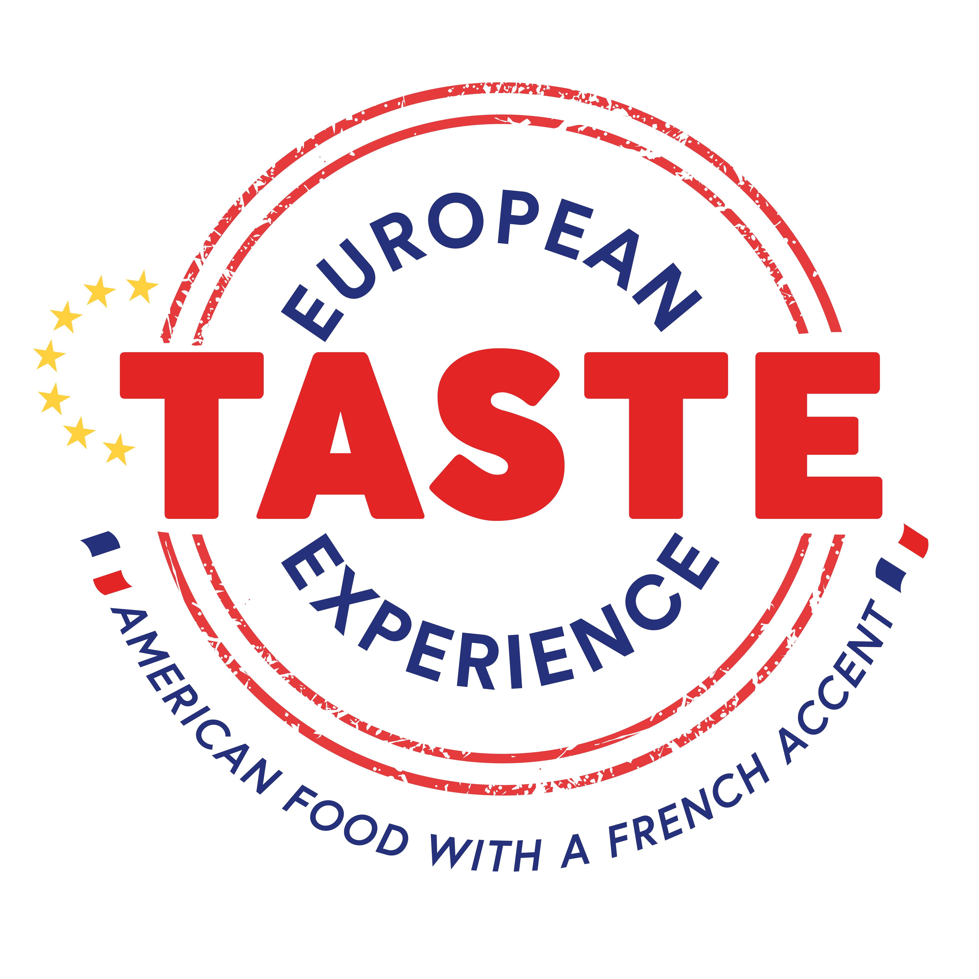

- For the actions detailed below, the agency should describe the objectives, the target audience, as well as the expected deliverables and should include a precise budgetary proposition. The proposal should take into account the compulsory EU signature and other graphic elements as stipulated in Regulation EC/AA44/2014 and related legislation. The selected executive agency will need to strictly adhere to these criteria for all actions planned and carried out, as non-compliance with these EU rules would lead to non-eligibility of the actions and loss of funding.

SUPPORT ACTIONS
Actions carried out by the executive agency under this program fall under five main types of activities:
- Public relations and communication
- B2B Roadshows
- Buyers ‘trips
- Point-of-Sale Promotions
- Trade fair Booth

These actions are detailed hereunder.

- Public relations and communication
- The agency should propose key messages to promote the program via public affairs and media actions. The agency should describe how the proposed actions will contribute to the overall objectives of the program. The public relations axis of this program should focus on social media, and include the creation of promotional material. The proposed actions should increase the visibility of ANIA’s actions in the US.
- Indicative budget: 100 000 €

- B2B Roadshows
- The agency should propose at least one B2B Roadshow per year. The proposed Roadshows should be complementary to the previously organized ones.
- Indicative budget: 150 000 - 200 000 €

- Buyers’ trips
- The agency should propose buyers’ trips. Considering the current referencing and listing of French products in stores, the agency should describe the most relevant major buyers to bring to France vs. program objectives. Trips can be organized in conjunction with in-store promotion programs but the agency may propose other solutions.
- Indicative budget: 70 000 - 100 000 €

- Point-of-sale Promotions
- The agency should propose a program with point-of-sale promotions. The agency should describe the way that the relevant stores will be selected in several cities and the steps of negotiation and preparation. The training and management of the animation teams on site should be described. Well-known franchises as local brands should be considered.
- Indicative budget: 100 000 – 150 000 €

- Trade Fair Booth
- The agency should propose a European and French pavilion at American food and beverage fairs. The selected trade fairs must be complementary to the already existing national French promotional programs, with no overlap. We have considered Natural Expo West, but the agency may propose other solutions.
- Indicative budget: 350 000 €

The selected agency will also be expected to participate in putting in place and in taking part in a validation committee. This committee will verify if the candidate companies interested in participating in the activities meet the criteria set by the EU program, in terms of quality and sustainability to the objectives of raising awareness and added value of European food products in the targeted markets.

An evaluation agency will also be selected at a later stage by ANIA to audit the program. The selected executive agency will be expected to facilitate the work of the evaluation agency as required throughout the project, e.g. provide information requested by the evaluation agency, participate in occasional meetings with the evaluation agency and take on board its recommendations.

The selected agency will be expected to assist ANIA in writing a proposal to the European Commission for financing. An envelope of 2 000 euros is reserved to this effect.

proposed planning

- 30 January: ANIA diffuses the call for tenders on all platforms
- 25 February by 16h00: Reception of the detailed propositions by e-mail
- 2 - 5 March: Notification of preselection results
- 9 – 10 March: Auditions of the pre-selected agencies
- 16 March: Notification of the chosen agency and detailed notification to the other agencies of non-selection
- 16 March – 15 April: Proposal writing in view of submitting the proposal to the European Commission for financing
- 15 April: Submission of the project

preselection criteria and selection criteria

The selection will be done by a jury composed of members of ANIA’s staff involved in the implementation of the project. Other personalities may complete the jury (administrators, representatives of member federations).

Preselection criteria:

- Financial viability (yes/no, eliminatory)
- Respect of the overall budgetary envelope (overrun of total budget eliminatory)

Selection criteria:
- Comprehension and strict respect of EU promotion rules (20 points)
- Experience with the food industry (10 points)
- Experience in the USA (presence in the USA will be considered as a plus) (10 points)
- Quality and coherence of the strategy, argumentation of proposed actions (30 points)
- Experience in trade fairs, buyers’ trips, in-store promotions, trade cocktails, B2B meetings and communication actions (20 points)
- Qualifications of the project management team (10 points)

A minimum score of 70 will be required for selection.

CONTACTS

Vanessa QUERE, International and Export Director (vquere@ania.net) and Juliette Chauveau, International Projects Manager (jchauveau@ania.net) are available to answer any questions agencies might have.

